For the optimization of XML parsing method, we have done checking of valid entries and non-duplicate entries in memory only. We have used Hash Map to keep the entry and check for duplicate or valid entries in the java file only instead of doing all the checking in stored procedures.

As the complexity of searching and inserting into Hash Map is O(1), and it is much faster than an Array List, we get the results very fast as compared to that which we would have got if we used Stored Procedure to compare.

Time taken:

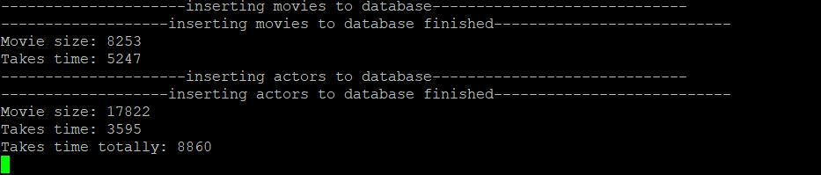

We have also used Auto Commit and prepare statement which helps in improving the optimization of the parser. We implemented the batch execution of the insert statement after all comparison and checking of entries was done in the memory. So the overall performance of the parser was improved.